Livrable L2.8
Plan de validation et bilan des tests sur la version finale de la plate-forme Papyrus

Nature:
Confidentialité:
Diffusion au sein du Consortium |  |  |  | Diffusion additionnelle
DocID: |  |  |  | Date de Création: | 23/04/2012

Projet | AGeSys | SP | 2
Auteur | P. Tessier | Organisation | CEA LIST

Projet | AGeSys | SP
Revues Internes | Sébastien Gérard | Organisation | CEA LIST

Table des Matières
1 Introduction 3
2 Papyrus Test Generation Framework 4
2.1 Requirements 4
2.2 Use Cases 4
2.2.1 Define list of element edit parts under test 6
2.2.2 Generate test model 6
2.2.3 Generate JUnit test code 7
2.3 Design 8
3 Perspectives 10
3.1 Current base of generated Junit tests for Papyrus diagrams 10
3.2 Handling of Generated Tests 10
3.3 Code Coverage 11
3.4 Execution time 12
3.5 Tests for Table Editors 12

Introduction
A very large part of the Papyrus code base is composed of the UML diagram editors code, based on Eclipse GMF (Graphical Modeling Framework). This framework automatically generates the complete code for a basic editor, taking as input an editor configuration file which is a model conforming to the GMFGen metamodel.

The general goal of this framework is to capitalize in such a model, the same way it has been used to generate the editor base, to also generate test code, and relieve developpers from the burden of manually writing tests every time the code for a diagram editor is regenerated.

The specific goals for the framework for generation of JUnit tests for the Papyrus UML diagram editors are :
* Automate the development of test cases for Papyrus diagrams
* Set the bases for a model-based testing approach
* Ease the transition towards test-driven development
Currently, the framework supports the generation of unit tests for a diagram editor, taking as input an input .gmfgen. See below the generation workflow to understand how it works.

Papyrus Test Generation Framework
This section details the user and developper documentation of the framework, including the design choices and the model-driven strategy to generate JUnit tests, while keeping flexibility to allow the testing of every GMFGen based editor.

Requirements
We have identified the following requirements for our framework of test generation.

- JUnit Generation (id=req01):
The framework shall allow to generate JUnit tests for UML diagram editors, its nodes and links
- Functional test cases (id=req02):
The framework shall test functional test cases: for example creation of elements, hide, delete, edition, drop from model explorer, among many others.
- Extensibility (id=req03):
The framework shall be extensible with new diagram editors based on GMF, and other technologies where an editor description is available as a model (such as Nattable).
- Functional Coverage (id=req04):
The framework shall attain complete functional coverage for a diagram editor.
- Code Coverage (id=req05):
The framework shall cover all the possible code coverable by generated tests (expected to be around 80%)

Use Cases
We present in this section the framework use cases, its justification within the test generation process and how to make it work. But before we dig into details, the following scheme shows an overview of the overall generation process.

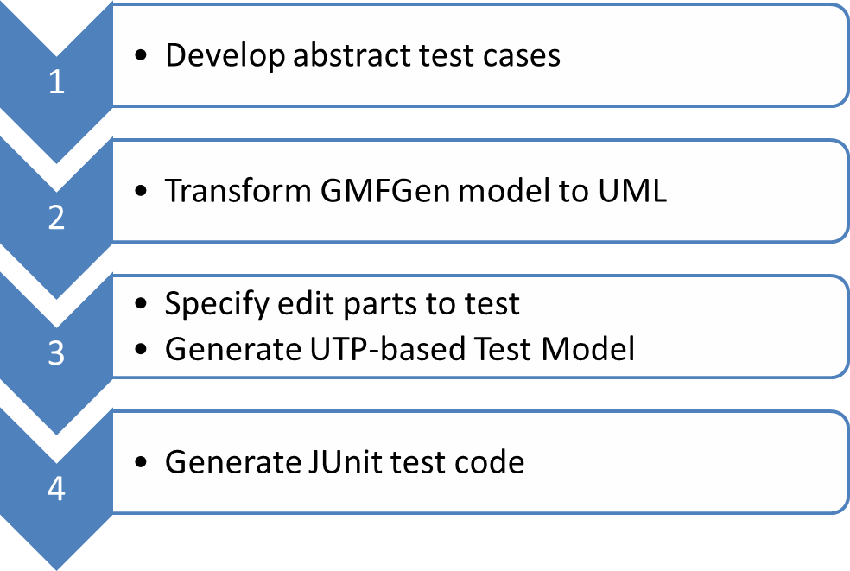

- Develop abstract test cases. Our framework generates tests that actually extend abstract test cases. These are classes with methods that implement the intended functionality for every type of test. The framework provides a pre-packaged set of abstract test cases, shown later in this section.
- Transform GMFGen model to UML. This is an automated step. As our model-driven solution to generate tests is based on UML models, and the GMF framework uses Ecore to represent the GMFGen metamodel, we perform a direct translation of the GMFGen model to UML. The following figure shows an example of this mapping.
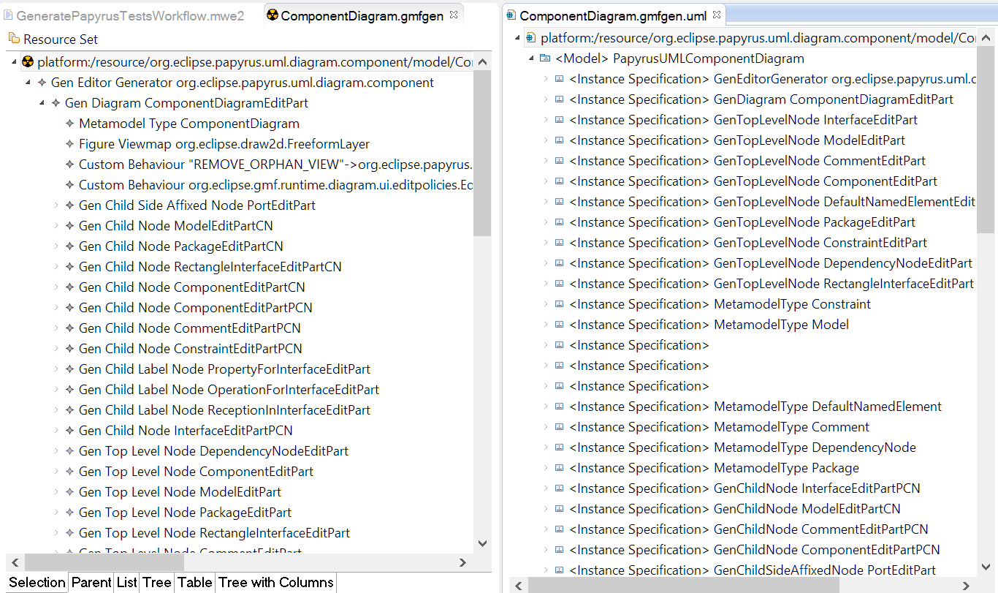
- Specify edit parts to test and Generate UTP-based Test Model Edit parts can be seen as the functional components of a diagram editor. Each one corresponds to a piece of functionality to edit models that we want to test.
- Generate JUnit test code. This is an automated step. Taking as input the model from the previous phase, the test code is generated. It takes the form of Junit test suites which extend the abstract test cases.

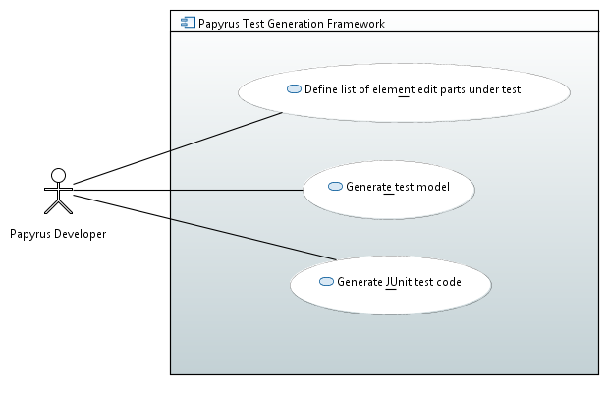

In Papyrus, every diagram editor has been developed as a separate plugin. Each one of them contains an already developed set of tests.

As a pre-requirement, the tests plug-in must have already been created.
Create tests plug-in, if it doesn't exist already. As a requirement, following the Papyrus development guidelines an Eclipse plug-in project must be created to contain the tests. Example: org.eclipse.papyrus.uml.diagram.component.tests.
Add the dependency in the plug-in manifest towards the testing framework: org.eclipse.papyrus.tests.framework.
Example: Generation for the UML Component diagram
Here is an example (componentdiagramtest.qvto):

import canonicalTests;

modeltype UML uses uml('http://www.eclipse.org/uml2/5.0.0/UML');

transformation componentdiagramtest(in gmfgenUml : UML, in gmfgenMm : UML, in frameworkBase : UML, in utp : UML, out testModel : UML) extends canonicalTests(in gmfgenUml : UML, in gmfgenMm : UML, in frameworkBase : UML, in utp : UML, out testModel : UML);
main() {
topContainerEditPart := "PackageEditPart";
topNodesToTest := Set{
"PackageEditPart",
"ModelEditPart",
"ComponentEditPart",
"InterfaceEditPart",
"CommentEditPart",
"ConstraintEditPart"
} ;
childNodesToTest := Set{
"ModelEditPartCN",
"PackageEditPartCN",
"RectangleInterfaceEditPartCN"
"ComponentEditPartCN",
"ComponentEditPartPCN",
"CommentEditPartPCN",
"ConstraintEditPartPCN",
"InterfaceEditPartPCN"
};
linksToTest := Set{
"UsageEditPart",
"InterfaceRealizationEditPart",
"ManifestationEditPart",
"ComponentRealizationEditPart",
"AbstractionEditPart",
"DependencyEditPart"
};
linksOwnedBySourceToTest := Set{
"GeneralizationEditPart"
};
gmfgenUml.rootObjects()[UML::Model]->map gmfgen2papyrusTest("org.eclipse.papyrus.uml.diagram.component.test");
}
Here is an example for the workflow launcher:
package org.eclipse.papyrus.uml.diagram.component.test.generation

import org.eclipse.emf.mwe2.runtime.workflow.WorkflowContextImpl
import org.eclipse.papyrus.tests.framework.mwe.GenerateTestsWorkflow
class ComponentDiagramGenerateTestsWorkflow {
def static void main(String[] args) {
val workflow = new GenerateTestsWorkflow()
workflow.uriPrefix = "platform:/resource"
runWorkflow(workflow);
}

def static void runWorkflow(GenerateTestsWorkflow workflow) {
workflow.gmfgenUri = workflow.uriPrefix + '/org.eclipse.papyrus.uml.diagram.component/model/ComponentDiagram.gmfgen'
workflow.testSrcGenLocation = 'test-gen-15072014'
workflow.qvtoScriptUri = workflow.uriPrefix + '/org.eclipse.papyrus.uml.diagram.component.tests/qvto/componentdiagramtest.qvto'
workflow.testModelUri = workflow.uriPrefix + '/org.eclipse.papyrus.uml.diagram.component.tests/model/ComponentDiagramTest.uml'
workflow.run(new WorkflowContextImpl());
}

}

Define list of element edit parts under test

Create the QVTO script for your diagram editor, detailing the name of the generated package of tests and the desired edit parts to test, as they are described in the gmfgen (See example below).

Generate test model
Create the generation launcher (either Xtend-based or Java-based) in an appropiate package, for instance org.eclipse.papyrus.uml.diagram.component.test.generation, in a file such as ComponentDiagramGenerateTestsWorkflow.xtend. Copy the example launcher below and replace with the values for the generation parameters for your own diagram editor. The parameters are:
gmfgenUri: URI for the input GMFGen file
testSrcGenLocation: Folder in the project where the launcher is located where the test code will be generated, for instance test-gen.
qvtoScriptUri: URI for the QVTO script
testModelUri: URI where the UML-UTP intermediate model will be generated. After launching the generation, this model provides an overview of all the generated test artifacts.
Launch the main method as a normal Java class.
The intermediate model and the JUnit code are generated.

Generate JUnit test code
The generated JUnit tests extend the abstract test cases defined in the Papyrus test framework base
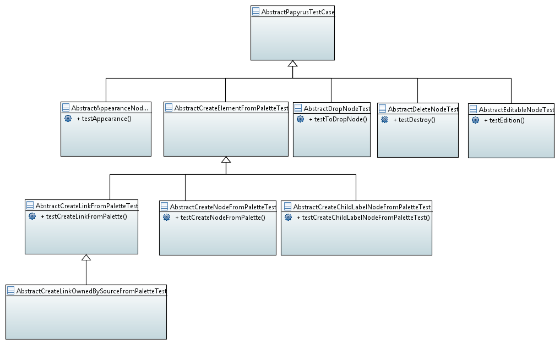
AbstractTestClassesDiagram

The following diagram shows an example of the generated test cases for the UML Class Diagram extending these classes. It also shows the use of the UTP (UML Testing Profile).

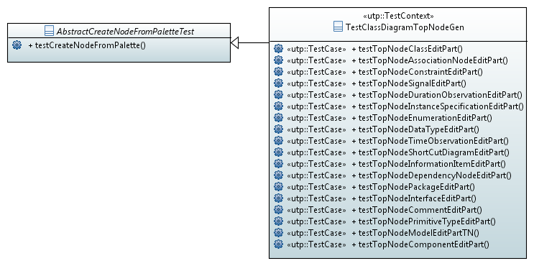
In this case, the generated test suite («utp::TestContext») contains all the methods to test the creation of nodes that the user can create at the root of a class diagram («utp::TestCase»).

Design
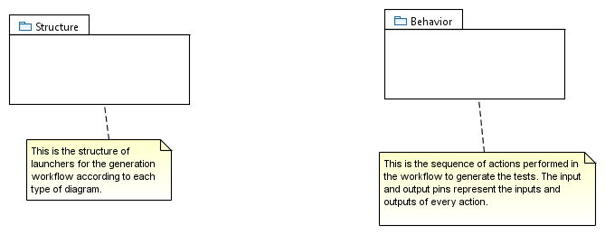
DesignOverview

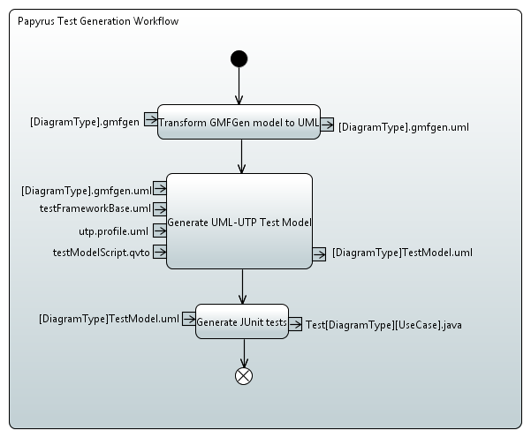
GenerationWorkflow

This is the sequence of actions performed in the workflow to generate the tests. The input and output pins represent the inputs and outputs of every action.

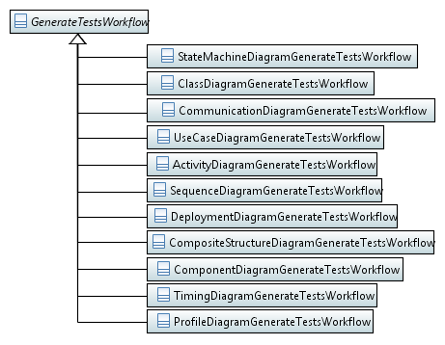
ClassDiagram

This is the structure of launchers for the generation workflow according to each type of diagram.

Perspectives

Current base of generated Junit tests for Papyrus diagrams

The following is the current count of tests written for each type of diagram. The first column shows the diagram type, the second

Number of tests | Without test-gen | With test-gen
Activity | 55 | 4768
Class | 133 | 6652
Communication | 6 | 563
Component | 33 | 1567
Composite | 126 | 12064
Deployment | 41 | 3597
Profile | 15 | 75031
Sequence | 297 | 1684
Statemachine | 13 | 420
Timing | 54 | 892
UseCase | 31 | 1198
Total for diagrams | 798 | 104873
Total for all tests | 9420 | 114293

Handling of Generated Tests
Here is a sample of the a generated test case for the relationship Dependency in generated test cases for the UML Class diagram editor.

/**
* Test to create link Dependency.
*/
@Test
@GeneratedTest
public void testLinkDependency() {
testCreateLinkFromPalette(
UMLElementTypes.getElementType(PackageEditPart.VISUAL_ID), UMLElementTypes.getElementType(ModelEditPartTN.VISUAL_ID), UMLElementTypes.getElementType(DependencyEditPart.VISUAL_ID), true);
}

The test case calls for the testCreateLinkFromPalette method, defined in the abstract superclass AbstractCreateLinkFromPaletteTest.

If we look closely at the semantics of this test, the validation action consists of creating a Package, a Model element, and a dependency between both. The last argument in the method call is a Boolean flag in which specifies is this test must pass successfully or not. In fact, for the case on link creation tests, the complete cross-product of all possible source and target nodes is generated.

It is therefore expected that some tests should fail. In this case, the model described in section 2.2.2 comes especially useful. The developer can edit this model to customize the generation, and gain better control of the generated tests. For our specific example, it’s about controlling the value of the “must pass” Boolean flag, either true or false.
The following diagram shows a snippet of the generated test model, showing the test case operations generated in the example of section 2.2.3 in the Papyrus Generic Table editor. The first column shows the name of the test operation, whereas the second column shows one of the features of UML operations; the exceptions that could be raised during execution of this operation. Two particular tests of this list must not pass: the creation of association nodes and dependency nodes (since they are not created individually by the user). We signal then that for both of these tests there is a raised exception, UnexecutableCommandException.

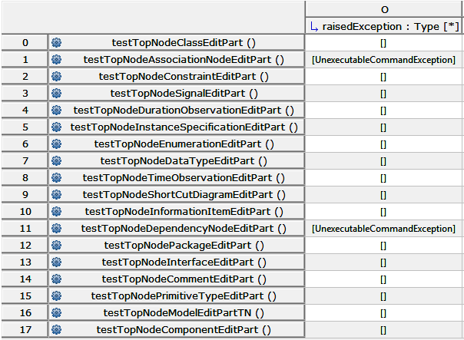

After setting these values for the test model, the generated code for the tests testTopNodeAssociationNodeEditPart and testTopNodeDependencyNodeEditPart will contain the “must pass” flag set to false.

Code Coverage
One of the most important quality criteria used to measure the effectiveness of tests is the percentage of the code base of Papyrus. The tests generated with this framework have allowed increasing this coverage with respect to the set of tests that were written manually.

For the class diagram editor, for instance, the initial set of 133 tests covered 28.20% of the code. By adding the tests automatically generated with this framework, the set grew to 6652 tests. The coverage analysis has shown several issues for which actions were taken immediately, thus increasing the code quality. The main issues were:

Detected dead code: 90% of the editor code is automatically generated by the GMF framework. A big part of this code is overloaded by the remaining 10% of custom code written manually. There is thus a large part which is never executed. It corresponds mainly to:
- Deprecated code, corresponding to edit parts (editor components) no longer used.
- Unused so-called canonical edit policies: The code handling the edition logic of the editor generated by default. A total of 56 classes could be thus safely removed from the base code.

The resulting coverage rate after performing this cleanup is 57.2%. The rest of the remaining uncovered code corresponds to code related to specific cases for which automated generation of tests has not been provided, since they have a much customised logic which imposes the individual analysis of branch execution. Some of these cases are, still in the example of the class diagram editor:
- Association Nodes and Dependency nodes. These kind of nodes actually represent a relationship, and cannot stand by themselves in the root container of the diagram. They need previously created source and target nodes.
- Side affixed nodes: There are model elements that consist of subnodes attached to sides of top nodes. This is the case of input and output pins for actions in activity diagrams, and templates for classes in class diagrams. Since their behaviour can change considerably (position of the node, connectable links…), the validation actions (i.e. assertions to test) may vary and thus it is preferable to manually provide tests.
- Redundant methods inside classes that are never invoked when performing the tested user functionality. These methods could be covered by writing manual tests targeting specifically those operations.

Execution time
As explained earlier, the framework generates the complete cross-product of model elements automatically. It is thus expected that the number of test cases increases considerably, going for most diagram editors from hundreds to thousands or tens of thousands.

It is also expected that the execution time of these steps will also increase. Still in the case of the generated tests for the class diagram editor, the execution time for the tests of this editor alone was 33 minutes. Considering that there are 11 diagram editors in Papyrus, this poses a challenge for continuous integration, and to preserve a test-driven development methodology among developers where the total set of tests is executed on a daily basis.

It became therefore important to find a strategy to speed up the execution time for the generated tests. Although the tests were initially generated to be mutually independent, we proceeded to concatenate them in a sequential execution where the memory resources could be shared, thus reducing load/unload times of editors and the whole infrastructure of the Eclipse workbench. We could thus reduce the execution of tests for the Class diagram editor to 3 minutes.

Tests for Table Editors
In the current Papyrus offering, graphical editors are presented for all the possible UML diagrams. Diagrams provide a very intuitive mechanism to visualize and edit moderate size models, when these consist of no more than 20 elements (some academic works even suggest the “magical number” of 7 +/- 2 elements) However, in the case of very large models, such as in the case of real-time and embedded systems development, the number of elements present in a single model can attain thousands of elements. It is not possible to develop this kind of models in a diagram editor.

In order to attend the needs of users working with such models, Papyrus offers also tabular editors. They are based on the Nattable widget, which allows developing Eclipse editors closely resembling Excel spreadsheets, with several features such as sorting, resizing of columns and rows, in-cell edition, automatic validation, among others.

Some of the tables that are offered by Papyrus today are:
- SysML Requirements Table
- SysML Allocations Table
- Papyrus Views Table

Every table type is defined in a configuration file which relies specifies several aspects of the target model editor:
- Type of objects represented in the table
- Features to be visualized in columns by default
- Label providers for feature names (i.e. column headers) and their values in cells
- Label providers to identify objects in rows (i.e. row headers).
- Editors for cell values: Simple text editor, multiline text editor, combo box of enumeration values, reference selector…

In the same manner that we provided tests for diagram editors based on GMF configuration files, we will also provide tests for Table editors. The test suites provided for every editor type will effectuate the following validation actions:

- Test that only model elements for the appropriate model type can be added, edited, deleted, dropped from the model explorer into the table editor.
- Test actions such as copy-paste, undo/redo, drag and drop for cell editors whose values are other objects.
- Test that column providers effectively allow to show columns for all valued features, both for UML base feature as well as the on-top added features via stereotypes.
- Test that different label providers display the appropriate labels for object identifiers and feature name and values.

